**Selective Detective**

Team: Parikshit Solunke, Stephen Lambert, Justin MacDonald

Github Link: <https://github.com/jusjustin/cs426_MacDonald_Justin_Asgn-7->

Bug Tracker: Github

Overview and vision statement

A massive cooperative multiplayer game where players collectively try to find a thief in an ever changing city. What’s unique about Selective Detective is that it can be played by 2 or as many people who can fit in the cave. A game is played like this. One player acts as a criminal trying to steal objects without getting caught by another group of players called detectives. Since the city is ever changing, this is not a simple task. The city will have NPC citizens walking around as well as moving vehicles for the thief to cloak himself behind. Aboveall, it is important for our team to create something simplistic so that anyone can play. Whether you are young or elderly, you can play. Our team intends on keeping the mechanics and controls to accomplish this. To add on this theme, our team envisions a cartoon/kid friendly theme to keep things in a fantasy.

Audience, platform, and marketing

* Target Audience: Free to play for everyone
* Platform: Pc/Cave2. The reason we chose this platform is to use the full capability of the cave 320 degree view.
* System Requirements: Two monitors are required so that the thief can conceal his identity.

Gameplay

* Detectives look around the scene and try to find the thief that is stealing random objects that appear. The thief can steal objects by pressing the ‘A’ button. And use the analog stick to move the thief around the map. At the end of the game, the detectives will be able to vote for who they believe the thief is. If the thief is identified, then the detetives win. Otherwise, the thief fooled all the detectives and they win.

Characters:

Playable Characters

* Thief

The thief’s job is to steal.

* Detective

The detectives are in charge of figuring out which character stole.

Non Playable Characters

* Civilians roam around the map, the thief’s task is to blend in with the civilians and steal undetected.

Story:

* Although we don’t have a definitive story. We’d have been playing around with the idea that the detectives collectively are working at an agency that’s located in a glass dome above the city. We’d use the tutorial to tell the players that they were hired onto this special task force and only they have the capacity to figure out the thief.

World:

The game will be based in a city environment. The world will be built with skyscrapers, vehicles, streets, lights, city themed props, ect...

Level Design:

Our level is city themed. So, we plan on creating a simple grid to populate buildings and eventually add streets. This simple design will make path finding easier. We also want the map to be simple to navigate so that detectives have a fair chance of identifying the thief.

Character Design:

In our game there are twenty characters with rigged bodies. Some characters are able to walk throughout the scene in a random order, while others remain idle. This was developed by using navigation, pathfinding,and walking/idle finite state machines with our animations.

Physics:

The Thief moves around the map attempting to steal. To create this we placed a box collider on the Thief to detect when the object is stolen. Additionally, we gave the Thief jump mechanics to move around the environment with ease.

Since the Cave uses the wand as a controller, we got inspired by a demo in which the player can grab blocks. We decided to demo a building that Detectives can grab and drop in search of the thief.

Media list

Interface Assets

* Tutorial
* Menu
* Thief Selection

Environments

* City layout
* Space
* Western

Players/Characters

* Citizens
* Thieves
* Detectives

Animation

* Walking
* Idel

Music and sound effects

* Footstep sound effect
* Sirens
* Plane sound effect
* Citizen talking
* Water sound effect
* Bird noises
* Honking

List detailing the following level components (short and sweet):

List of Level Geometry

* 3D Plane
* Buildings
* Characters
* NPCs (citizens)

List of Characters and Topology for animation (what paths they will follow)

* Walking state
* Going to a building state
* Idle State

List of Character Animations necessary (e.g, idle, walk, run, pull-lever and death.)

* Walk
* Idle
* Thinking
* Waving
* Bobbing Head
* Sitting
* Running
* Dancing
* Exercising

List of Animations necessary for Door, Puzzle & Artifact.

* Spinning stolen object

Specified Tools:

* Repositor and Bug Tracking: Github
* Scheduling: Trello
* Communication: Text, Discord
* Game Engine: Unity

UI Design

i) The red bb8 character is too bright, so the detective in our game will be able to easily spot the character that stole an object. This breaks the color scheme principle in our game, we fixed this by making our characters colors reflect similar colors that are in our game.

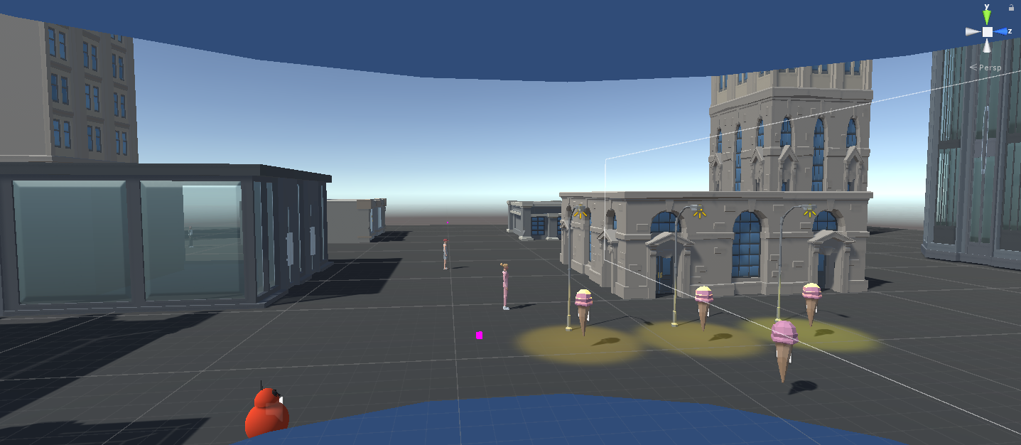

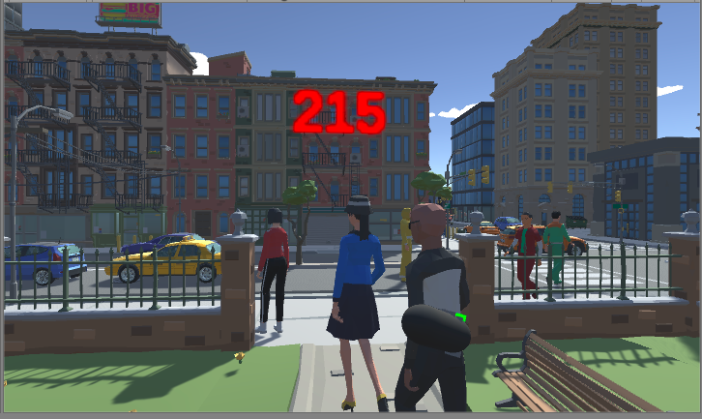

ii) The cones in game are also too bright, so the detective will be able to easily spot which object was stolen in the game, making it easier for the thief to be detected. We fixed this by making our objects have colors that are similar to other objects in the game.

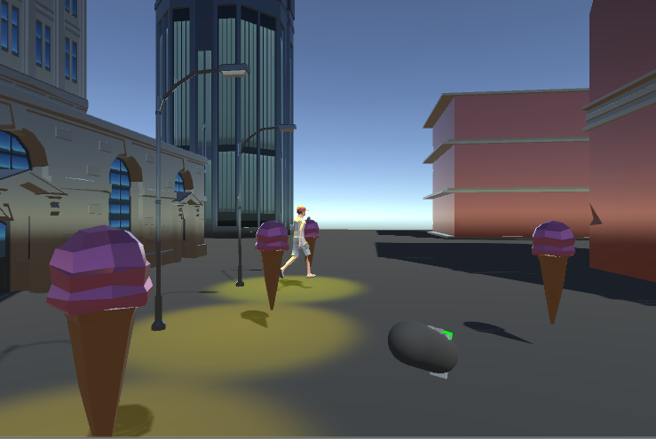

iii) It is not clear that a user is able to pick up a building inside the cave, this breaks the learnability principle, so we fixed this by highlighting the building when it is selected, so that the user knows that they are able to pick up a building.

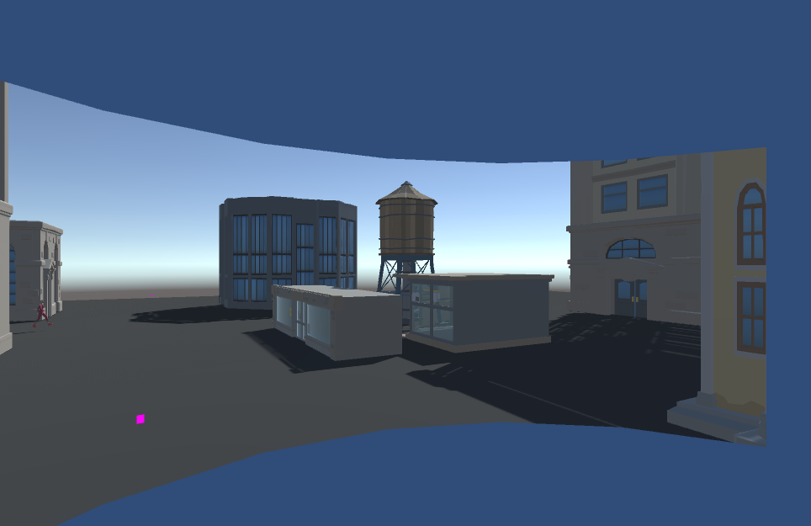

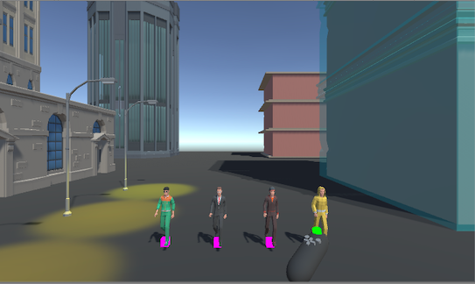

i) It is not clear how to play the game, how to move around in the game, or what the player should be doing in the game. This breaks the clarity principle, we fixed this by adding a tutorial scene, so that the player knows how to play the game.



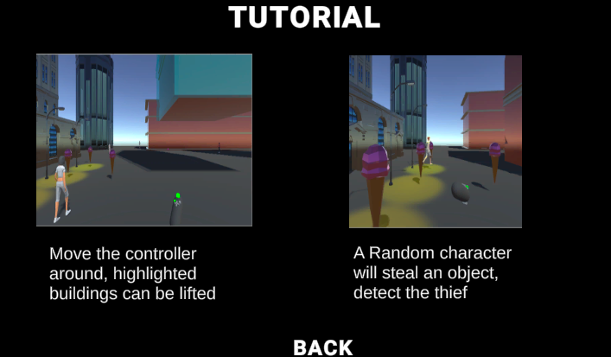

ii) There is no main menu in the game, when the game is played, instead the player just starts on the scene, this breaks the clarity and consistency principle, we fixed this by adding a menu scene.



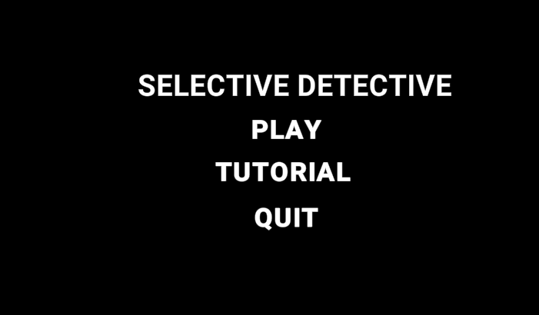

iii) There are not many buildings in our scene, this breaks the consistency principle, so we fixed this by changing our scene, so that it looks more like a city.

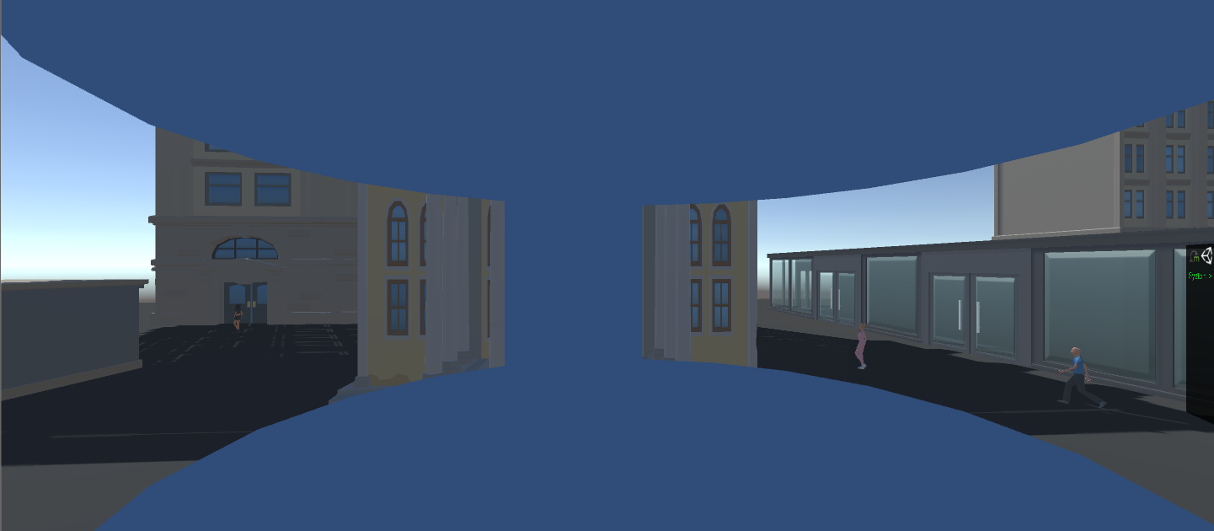

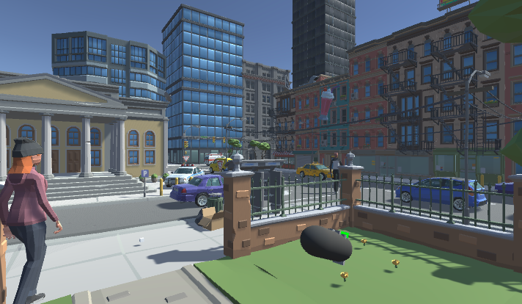

i) The ground texture does not represent a city street, this breaks the consistency principle, we changed the ground texture to look like a city street.



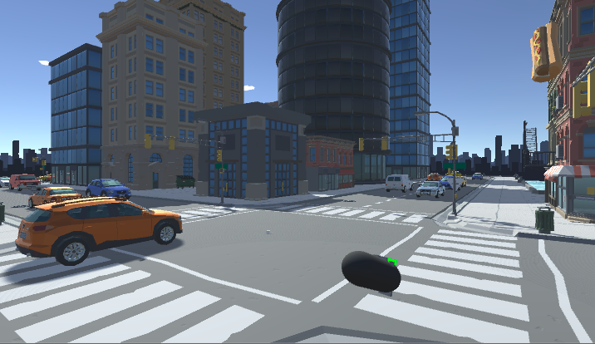

ii) The game starts with only one character that can be played, this breaks the clarity and learnability principles, we fixed this by allowing the user to select a player.



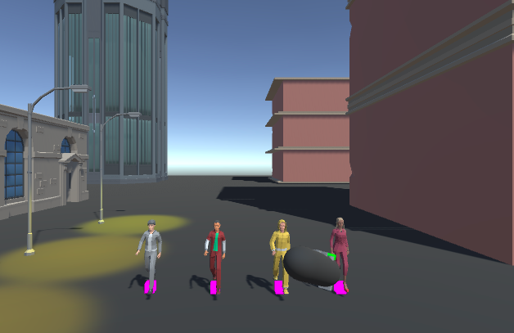

iii) The color of the buildings is saturated, this breaks the color scheme principle, we fixed this by making the textures on our buildings less saturated.



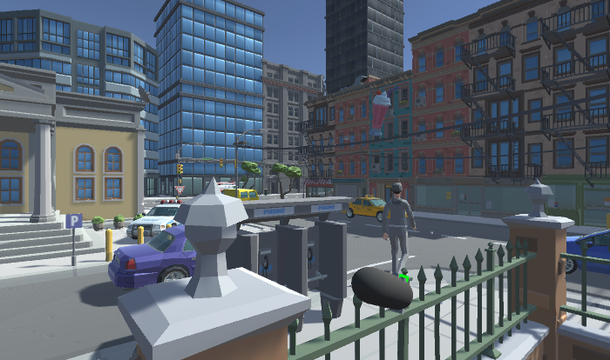

Sound Design

<https://www.youtube.com/watch?v=dmclc2pIRnk>

Dialog sounds

-Whenever text is being displayed.

-Sounds add importance to the dialog box. The impact is subtel.

-To draw the attention of the play to read the text.

-The sound is repetitive. But I think it’s okay since it’s not an annoying sound.

-The sound might be a recording of clicking

-The balance is good since it’s the only sound when being played. It’s nice and quiet but enough to bring the attention to itself.

Gameplay song

-Takes place all throughout the gameplay

-The song is upbeat but fast paced. The song helps uplift the cartoon visuals present in the scene.

-The music helps fill the silence in the scene.

-Yes it’s repetitive! The song could be a series of loops and randomly loop a certain number of times till the next loop.

-The song is probably a 30 second loop that uses whistle sounds.

Vehicles moving

-Sound takes place as a bus moves across the screen

-There’s a panning effect to let players que into the position of the bus. The loudness and softness are balanced as it pans. So it isn’t overwhelming to the player but eventually captures the player's attention.

-The “vroom” sound is quite repetitive. They could randomize the pitch.

-The sound design is used to possibly hint the possibility that the thief is behind the bus.

-They might have created this sound by recording a noisy engine.

-The bus sound definitely drowns out other sounds. This is distracting to the player.

Countdown

-At the 30 second mark, a 5 second countdown beeps every count.

-Visual players can see the numbers count down and they pop out at the player. The impact is strong.

-This sound is used to stress the player and alerts them that time is running out.

-It isn’t repetitive.

-Sounds like a tone with the tail end of the sound drowning out.

-This sound is loud but short. It disrupts the sound environment to stress the player but after 5 seconds stops.

Fruit pickup sound effect

-Once the player picks up the fruit it plays

-No very visually present. The impact of the sound is noticeable but semi-loud then fizzles. Kinda like a notification sound.

-To indicate that an object is stolen.

-It isn’t repetitive.

-The sound might have been made from a ringing sound

-The balance is good. It is unique enough to fit with the visuals but notifies players.

Snapshot sound

-Every 30 seconds a snapshot is taken to give a hint. A “ticking” sound is played.

-The ticking has a stress impact on the snapshot. The strength of the sound is effective since all other sounds are faded out to give the “ticking” sound more of an impact.

-To get the attention of the player and also remind them that time is ticking away.

-It isn’t repetitive.

-A recording of an old stopwatch or clock.

-Balance is good. The fading out of other sounds gives it more efficicist.

Calendar/Schedule

